

March 2021

**Inclusive aid to support people with psycho-social disabilities**

## Introduction

## The objective of this project is to identify how much official development assistance (ODA or aid) goes to Kenya, Uganda and Zambia; how much of this aid is disability relevant and disability inclusive (e.g. CRPD complaint) and how much goes to psycho-social disability projects globally by what donors and through which implementing partners with a particular focus on Kenya, Uganda and Zambia. The data and analysis will inform an advocacy paper Validity is planning to publish in May 2021.

In 2019, Development Initiatives (DI) created a keyword search methodology which examined records from the Creditor Reporting System (CRS) for projects which contained titles or descriptions which indicated that the purpose was relevant to individuals with disabilities up to and including 2017.[1] In February 2020, the OECD DAC released the 2018 compendium of international aid in the CRS. This release of the CRS contains a new marker for the ‘inclusion and empowerment for people with disabilities’.[2] The marker asks donors to indicate whether individual projects are one of ‘principally’, ‘significantly’ or ‘non-targeted’ for the purpose of the inclusion and empowerment of people with disabilities, much in the same way that previous project markers function—such as the gender empowerment marker, or the Rio markers. Projects classed as ‘principal’ are projects with a primary and direct aim relevant to persons with disabilities and ‘significant’ are projects with a partial but still direct aim relevant to persons with disabilities.

This project will combine analysis of the DAC’s new disability marker and a revised keyword methodology to quantify overall ODA, disability-relevant ODA, and ODA relevant to persons with psycho-social disabilities in Kenya, Uganda and Zambia. This analysis used the OECD DAC data for the period 2015-2019.

## Overall aid to Kenya, Uganda and Zambia

First, we identify the amount of ODA going to Kenya, Uganda and Zambia. To this end, the OECD DAC CRS (Creditor Reporter System) database is used to quantify overall aid disbursements to the focus countries. All activities from all donors are included, irrespective of whether they are disability-relevant or not.

Figure 1: Overall aid to Kenya, Uganda and Zambia, 2015-2019

Source: Development Initiatives based on OECD DAC CRS.

Overall disbursements from donors to all developing countries[3] globally have increased slightly across the period from 2015-2019, and most notably between 2015 and 2016. In 2015, US$177.3bn was disbursed compared to US$200.7bn in 2019, equivalent to a 13% increase. This increase has not been observed equally across recipient countries, channels, or project objectives.

Between 2015 and 2019, disbursements to Kenya, Uganda and Zambia, the three focus countries, have increased from $U5.8bn to $US7.3bn, equivalent to a 27% increase, 14 percentage points greater than the global increase. Notably, however, this increase has not been observed equally. Despite Kenya and Uganda seeing increases in the region of 30%, Zambia has only seen an 11% increase across the period, with consistent decreases since 2017. In volume terms, disbursements to Kenya have increased by $US0.9bn across the period, compared to an increase of $0.5bn in Uganda and $US0.1bn in Zambia. In Kenya, ODA grant disbursements have decreased by 10% and ODA loan disbursements have almost doubled across the period.

Figure 2: Top donors to Kenya, Uganda and Zambia, 2015-2019

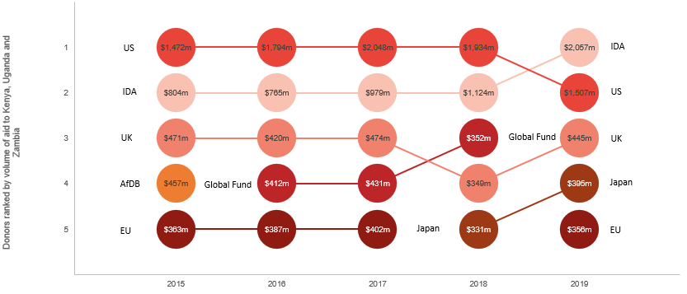

Source: Development Initiatives based on OECD DAC CRS.

In the period, the United States was the largest annual donor in all but 2019 where the International Development Association (IDA) disbursed $US2.1bn. From 2015-2019, the United States disbursed $US8.8bn to Kenya, Uganda and Zambia, equivalent to 27% of total receipts of the three countries. Other countries and organisations disbursing consistently large volumes to these countries include IDA ($US5.7bn across the period) and the UK ($US2.2bn across the period).

Figure 3: Delivery channels to Kenya, Uganda and Zambia, 2015-2019

Source: Development Initiatives based on OECD DAC CRS.

International aid takes many routes to reach its point of delivery. In addition to recipient governments, non-governmental organisations (NGOs) form a key channel of delivery for international aid, enabling donor governments to fund effective development projects at an international and national level.

Overall aid is channelled mostly through recipient governments in Kenya, Uganda and Zambia (44% of all aid from 2015-2019). NGOs are the second most used channel; International NGOs channelled over 16% of all aid over the period and donor-country-based NGOs have channelled 12%. On a similar magnitude, donor governments have channelled 12% of all disbursements.

## Disability-relevant aid to Kenya, Uganda and Zambia

Utilising the keyword methodology in combination with the DAC’s own disability inclusion marker, aid which is relevant to all aspects of disability was identified. Disability-relevant aid was classified as either ‘principal’ (aid projects with a primary and direct aim relevant to persons with disabilities), or ‘significant’ (aid projects with a partial but still direct aim relevant to persons with disabilities).

Figure 4: Overall disability-relevant aid to Kenya, Uganda and Zambia as a proportion of all ODA has increased since 2015

Source: Development Initiatives based on OECD DAC CRS.

Over the period 2015-2019, total disability-relevant aid to the focus countries totalled $0.9bn, representing a share of less than 3% of all ODA in this time. The share of disability-relevant aid increased consistently year-on-year from 2.0% in 2015 to 3.5% in 2019 (Figure 4).

The split of aid with a principal or significant disability purpose shows only a small minority of disbursements have as a principal disability objective: just 12.9% of all disability-relevant disbursements since 2015. This analysis suggests that the vast majority of disability-relevant aid is delivered in diverse and multi-purpose aid packages which cover broad groups of vulnerable populations, rather than targeting persons with disabilities directly.

Figure 5: Top donors of disability-relevant aid to Kenya, Uganda and Zambia, 2015-2019

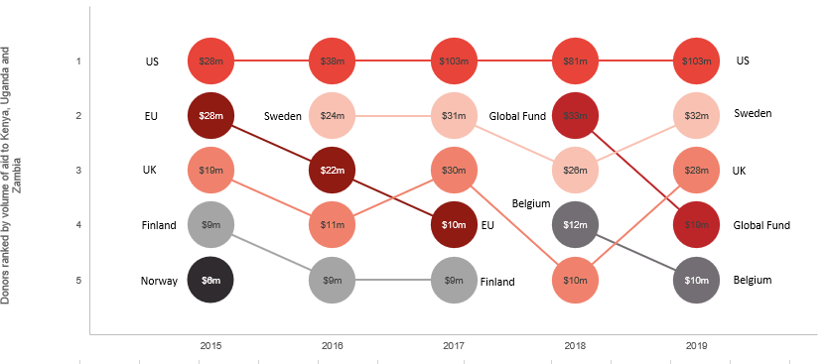

Source: Development Initiatives based on OECD DAC CRS.

Throughout the period, the US represented the largest donor of disability-relevant aid, with over $US350m in disbursements. Between 2015-2019, USA, UK, EU institutions and Finland have consistently appeared in the top ten donors of disability-relevant aid, with the first two having been consistently in the top five. Despite this considerable consistency, these four donors’ disability-relevant disbursements do not exceed $0.6 billion in total across the period in question.

Figure 6: Delivery channels of disbility-relevant aid to Kenya, Uganda and Zambia, 2015-2019

Source: Development Initiatives based on OECD DAC CRS.

In sharp contrast to the picture of all aid, where recipient governments are the largest players, the majority of disability-relevant aid is channelled through NGOs (both international and donor country based). Almost 70% of disability-relevant aid from 2015-2019 was channelled through NGOs, with 36% by donor country based NGOs and 34% being delivered by international NGOs and just 2% by country based NGOs. This is 41 percentage points greater than the proportion disbursed through the same for overall aid. Recipient governments play a considerably smaller role with only 4.2% of disability-relevant aid being delivered through them in 2019 (45.9 percentage points less than for overall aid).

## Psychosocial disability-relevant aid to Kenya, Uganda and Zambia

Psychosocial disability-relevant aid is a subset of overall disability-relevant aid. Projects which seek to assist in and improve the livelihoods of persons with psychosocial disabilities as a direct and explicit goal are classified as aid relevant to psychosocial disabilities. Such aid projects were identified using a specialised keyword and phrase methodology.

Figure 7: Psychosocial disability-relevant aid to Kenya, Uganda and Zambia as a proportion of disability-relevant aid fluctuates considerably but has also increased across the period

Source: Development Initiatives based on OECD DAC CRS.

Over the period 2015-2019, psychosocial disability-relevant aid to the focus countries totalled $24.2m, representing a share of less than 3% of disability-relevant ODA in this time. Of these disbursements, the majority (nearly $17m) have a principal objective of disability assistance or empowerment.

There is considerably volatility in the volume of disbursements going to projects relevant to persons with psychosocial disabilities due to the low number of projects. There is a considerable spike in 2018 and 2019 (Figure 7) due to multiple new large psychosocial disability-relevant projects regarding mental health and psychosocial support, mostly in Kenya and Uganda.

Figure 8: Top donors of psychosocial disability-relevant aid to Kenya, Uganda and Zambia, 2015-2019

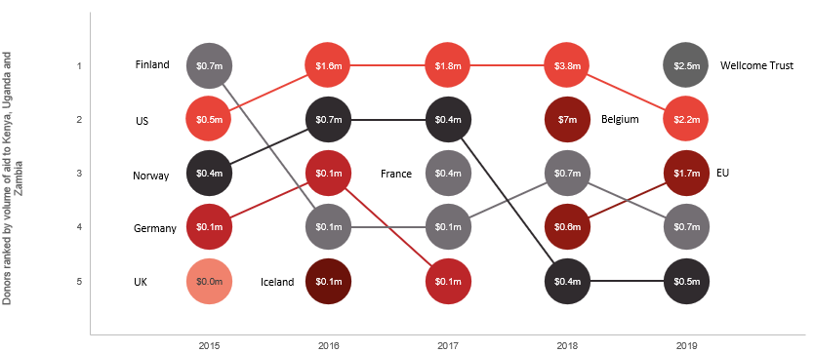

Source: Development Initiatives based on OECD DAC CRS.

Due to the previously mentioned volatility, there is less consistency among donors to psycho-social disability-relevant projects. This results in inconsistent quantities of aid being disbursed to projects considering persons with psychosocial disabilities. However, the US, Norway and Finland are consistently positioned in the top 5, the US disbursing over 40% of all psychosocial disability-relevant aid ($9.9m in volume terms). Finland and Norway both consider persons with psychosocial disabilities to a greater extent than many donors; both disburse more than 5% of their disability-relevant aid to projects also relevant to persons with psychosocial disabilities.

Figure 9: Delivery channels to psychosocial disbility-relevant aid Kenya, Uganda and Zambia, 2015-2019

Source: Development Initiatives based on OECD DAC CRS.

Adding further to the distinction between channelling of all aid against disability-relevant aid, donor-country-based NGOs play the largest role in channelling of aid relevant to persons with psychosocial disabilities, disbursing nearly 90% of the total. International NGOs and donor governments both disburse 5% each but the role of developing-country-based NGOs and recipient governments further reduces to negligible disbursements.

## Methodology

#### Keyword search approach

1. Project titles and short descriptions (which can be 150 characters long) of the OECD DAC CRS entries will be searched using principal terms to identify projects with ‘principal’ objectives relevant to people with disabilities. (Table 1 below lists proposed the search terms used).
2. Long descriptions (which allow more characters to be entered for each project) will be then searched for using the same principal terms. Projects captured in the search of long descriptions were marked as ‘significant’, on the assumption that disability assistance or empowerment is one objective of a wider programme.
3. A secondary search using significant terms will be carried out on the project titles, short descriptions and long descriptions of all projects not already marked as ‘principal’ or ‘significant’. These terms aim to capture a pool of projects for which disability assistance or empowerment is part of a wider programme.
4. In addition, another search is used for key channel names of organisations that solely work on projects with ‘principal’ objectives relevant to people with disabilities.
5. Projects which are marked by donors to have a ‘principal’ or ‘significant’ objective of disability assistance or empowerment are also included at this stage if not already identified.
6. In a similar way, false positive search terms that would create incorrect classifications will be used to identify projects that appeared to be disability-relevant in the previous steps. These projects will be manually examined to determine whether they represent programmes of which disability assistance or empowerment is a principal or significant objective, or not an objective at all. False positive search terms will be determined based on a manual check of primarily identified records.

### Keyword list for disability-relevance

All keyword matches are conducted in lowercase. The keyword approach uses a method known as ‘regular expressions’ to match partial and dynamic phrases in the keyword list. For example, the keyword string *‘disab’* will match all instances of the words *‘disability’* and *‘disabled’*. Special symbols are also used in regular expressions, for example, a period (*‘.’*) is a wildcard, which will match any single character in its place. Other symbols include the use of curly brackets, which define the length of a wildcard: *‘.{0,1}’* will match any one or zero characters in its place; and the use of *‘\\b’* to represent the boundary of a word, be that a punctuation or space character.

Psychosocial disability-relevant aid is a subset of overall disability-relevant aid. Of the keywords listed below to identify disability-relevance, some have been used to also identify psychosocial disability-relevance.

|  |  |
| --- | --- |
| Set | Terms |
| Disability: principal terms | *disab,discapaci,incapaci,minusválido,invalidit,infirmité,d-isab,disorder,handicap ,impairment,impaired,pwd,gwd,cwd,chronic health,chronic ill,maladie chronique,enfermedad crónica ,deaf,sordo,sourd,blind,ciego,aveugle,eye health,with special needs,con necesidades especiales,besoins spéciau,besoins spécifiques,special needs education,disabilities and special needs,autistic,autism,autist,mental health, santé mentale, salud mental,prosthe, prosthè, prótesi,mobility device, dispositivo de movilidad, dispositif de mobilité,wheelchair, fauteuil roulant, silla de ruedas,plegia,paralys,hearing aid,audífono,dispositif d'écoute pour malentendant,amputation, amputee, amputé, amputa,schizophreni, esquizofrenia, schizophrénie,bipolar,leprosy,sign language, langage des signes, lenguaje de señas,arthriti, artritis, arthrite,rheumat, rhumat, reumat,dementia, démence, demencia,spina ,hydrocephalus, hidrocefalia, l'hydrocéphalie,diabetes, diabète,atlas alliance,atlas allinance,abilis foundation,zapdd,special education, educación especial, éducation spéciale,special needs education, special need education,learning difficult, difficultés d'apprentissage, dificultades de aprendizaje,learning disa, discapacidad de aprendizaje,trouble d'apprentissage, learning problem,trisomy.{0,1}21, trisomie.{0,1}21, trisomía.{0,1}21,down syndrom, syndrome de down, síndrome de down,cerebral, cérébrale,crpd,cognitive dis, discapacidad cognitiva,déficience cognitive, cognitive defici,cognitive delay, delayed cognitive,fetal alcohol syndrome,developmental delay,pmld,neuro.{0,1}development,neuro.{0,1}diverse,sclerosis, sclérose,albinism, albino,assistive technology, tecnología de asistencia, la technologie d'assistance,assistive devices, dispositifs d'assistance, dispositivos de ayuda,reasonable accommodation, acomodación razonable, acomodaciones razonables, aménagements raisonnables, accommodement raisonnable,inclusive education, éducation inclusive,educación inclusive,accessibility,accesibilidad,accessibilité,workplace accommodations, aménagements en milieu de travail, alojamiento en el lugar de trabajo,people with limited capacit, personnes avec une capacité.{0,1} limitée, personas con capacidad.{0,2} limitada* |
| Disability: significant terms | *vulnerable group,vulnerable people,vulnerable population,vulnerable individual,vulnerable girl,vulnerable women,vulnerable boy,vulnerable men,vulnerable refugee,who are vulnerable,which are vulnerable,vulnerable child,marginali.ed group,marginali.ed people,marginali.ed population,marginali.ed individual,marginali.ed girl,marginali.ed women,marginali.ed boy,marginali.ed men,marginali.ed refugee,who are marginali.ed,which are marginali.ed,marginali.ed child,marginali.ed and young,war victim, victimas de guerra, victimes de guerre, victim. of war,landmine victim, victime de mine, víctima de minas terrestres,landmine survivor, sobreviviente de minas terrestres, survivant d'une mine,inclusive education, éducation inclusive, educación inclusiva,inclusive employment, empleo inclusivo, emploi inclusive* |
| Psychosocial disability terms | *incapaci,minusválido,invalidit,infirmité,disorder,pwd,gwd,cwd,chronic health,chronic ill,enfermedad crónica ,with special needs,con necesidades especiales,besoins spéciau,besoins spécifiques,special needs education,autistic,autism,autist,mental health, santé mentale, salud mental,prosthe, prosthè, prótesi,paralys,schizophreni, esquizofrenia, schizophrénie,bipolar,dementia, démence, demencia,learning difficult, difficultés d'apprentissage, dificultades de aprendizaje,learning disa, discapacidad de aprendizaje,trouble d'apprentissage, learning problem,trisomy.{0,1}21, trisomie.{0,1}21, trisomía.{0,1}21,down syndrom, syndrome de down, síndrome de down* |

Notes

1. Development Initiatives, 2019. *How well is aid targeting disability?* Available at: <https://devinit.org/blog/how-well-aid-targeting-disability/>
2. Development Assistance Committee, 2018. *Proposal to introduce a policy marker in the CRS to track development finance that promotes the inclusion and empowerment of persons with disabilities.* Available from: <http://www.oecd.org/officialdocuments/publicdisplaydocumentpdf/?cote=DCD/DAC/STAT(2018)39/REV1&docLanguage=En>
3. Developing countries are considered by the OECD DAC to be any ODA eligible country on the ‘List of ODA Recipients’. Available at: http://www.oecd.org/dac/financing-sustainable-development/development-finance-standards/daclist.htm